**SIDDHARTH TIWARI R2142210949 500095935 BATCH -3**

**Lab Exercise 9– Creating Multiple EC2 Instances with for_each in Terraform**

**Objective:**

Learn how to use for_each in Terraform to create multiple AWS EC2 instances with specific settings for each instance.

# Prerequisites:

* Terraform installed on your machine.
* AWS CLI configured with the necessary credentials.

# Steps:

1. **Create a Terraform Directory:**

**mkdir terraform-ec2-for-each cd terraform-ec2-for-each**

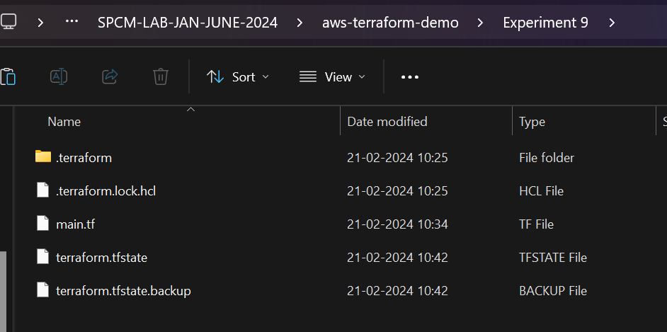

* + Create Terraform Configuration Files:
  + Create a file named main.tf:

## # main.tf

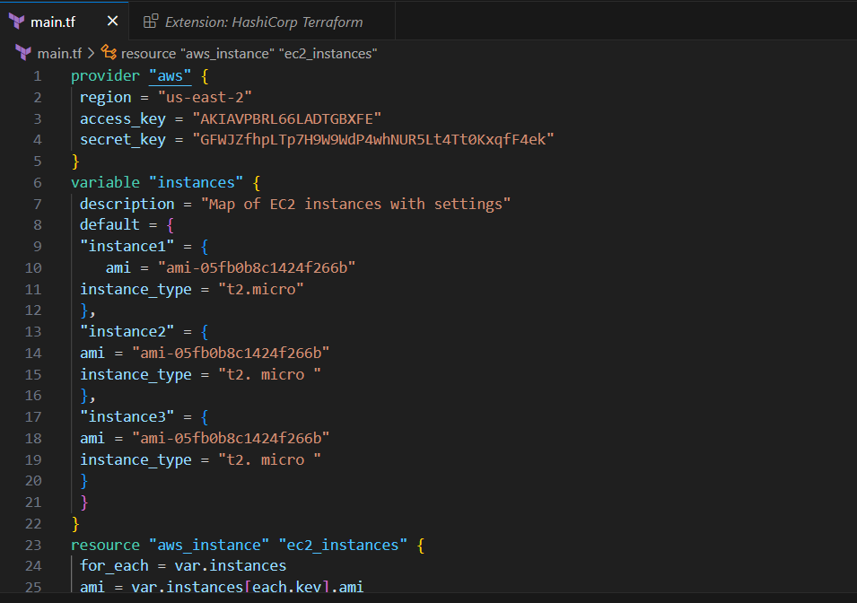

* In this configuration, we define a variable instances as a map containing settings for each EC2 instance. The aws_instance resource is then used with for_each to create instances based on the map.

# Initialize and Apply:

* + Run the following Terraform commands to initialize and apply the configuration:

**terraform init terraform apply**

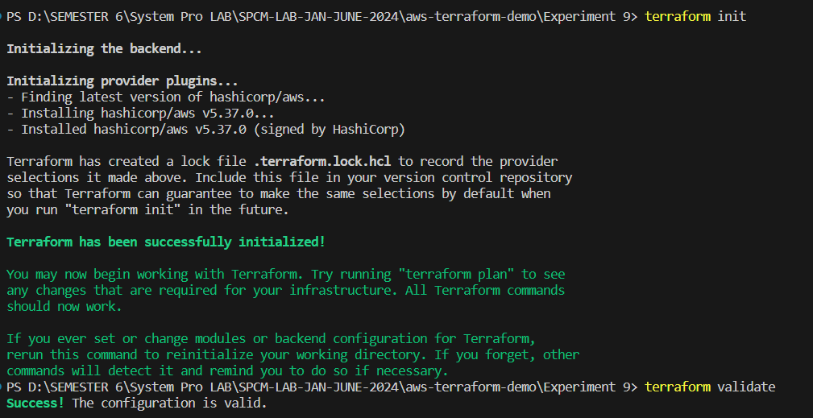

* + Terraform will prompt you to confirm the creation of EC2 instances. Type yes and press Enter.

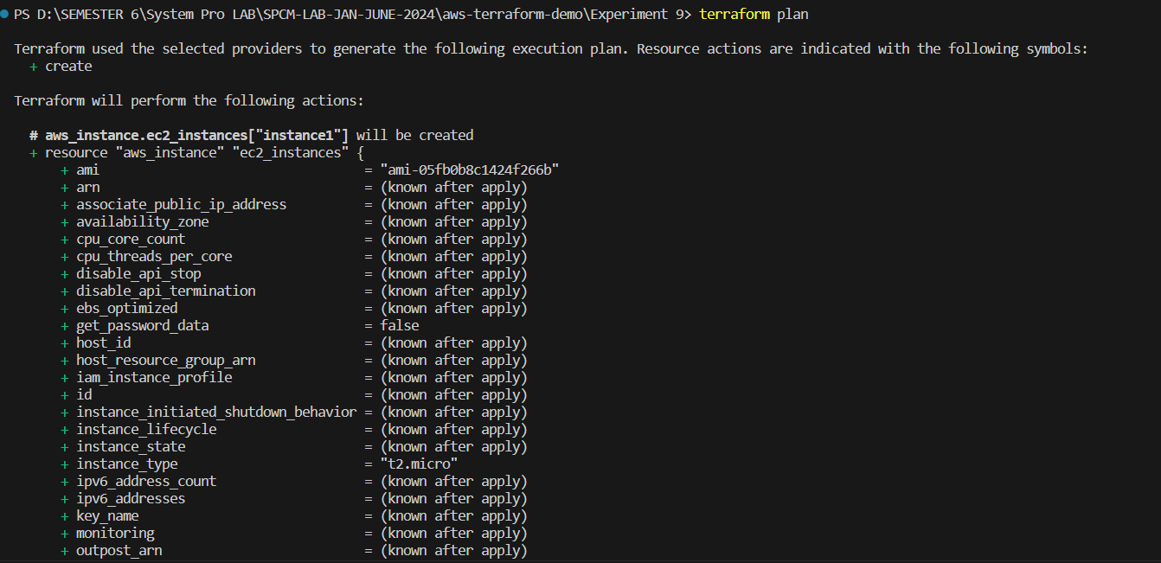

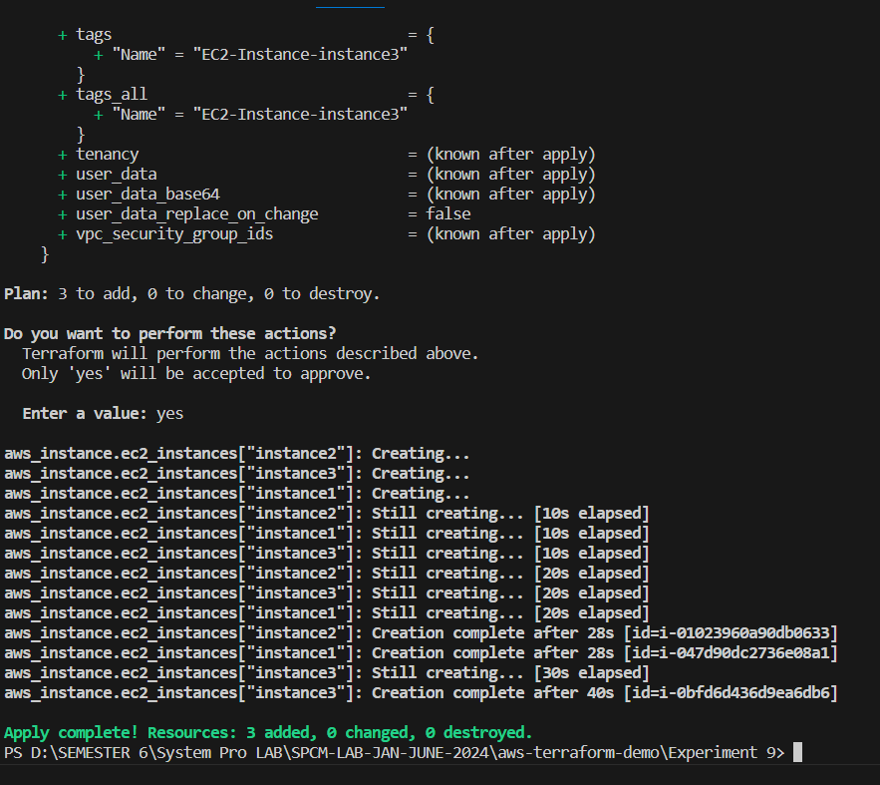

# Verify Instances in AWS Console:

* + Log in to the AWS Management Console and navigate to the EC2 service.
  + Verify that the specified EC2 instances with the specified names and settings have been created.

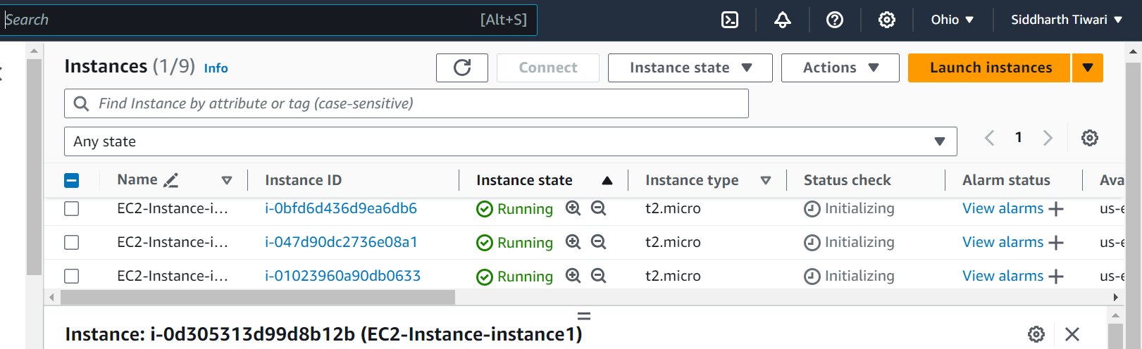

# Update Instance Configuration:

* + If you want to modify the EC2 instance configuration, update the main.tf file with the desired changes.
  + Rerun the terraform apply command to apply the changes:

**terraform apply**



# Clean Up:

* + After testing, you can clean up the EC2 instances:

**terraform destroy**

* + Confirm the destruction by typing yes.

# Conclusion:

This lab exercise demonstrates how to use the for_each construct in Terraform to create multiple AWS EC2 instances with specific settings for each instance. The use of a map allows you to define and manage settings for each instance individually.